29.22: a)
b) The potential difference between the ends of the rod is just the motional emf 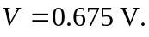
c) The positive charges are moved to end b, so b is at the higher potential.
d) 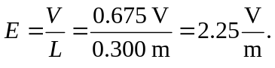
e) b

